|  |  |
| --- | --- |
| C:\Users\e0294398\Pictures\EGC Upward & Onward Logo.jpg | Eastern Goldfields College  Year 11 Mathematics Methods Investigation 4 |

Name:_________________ **Total marks: 50** **Time: 45 minutes**

**Varying speeds**

In this investigation calculations of speed are required. For each calculation one should assume that the distance the object has travelled from its starting point continues to increase, i.e., the object does not turn around.

The formula for calculating speed: 

**Question 1 (7 marks)**

A car is speeding on the freeway and the graph below shows its distance from the city (*d*), in kilometres, over a period of time (*t*) in minutes

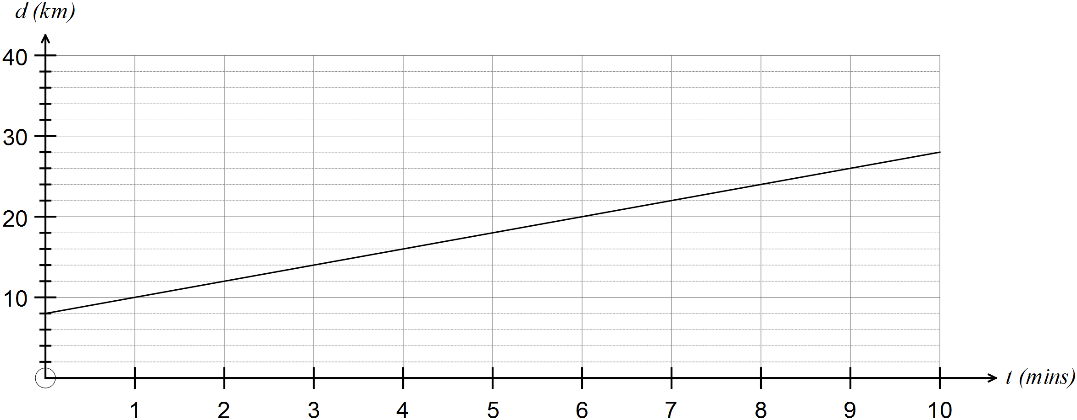

(a) Determine, in km/min, the average speed of the car (3)

(i) over the 10 minutes

(ii) during the first five minutes

(iii) during the first minute

(b) Determine the rule for the relationship between distance (*d*) and time (*t*). (2)

(c) If the relationship between distance and time, as shown in the graph, were to continue, how would the speed change over time? Justify your answer. (2)

**Question 2 (6 marks)**

For each section of the journey a train takes as it leaves the city, the distances travelled, the times taken and the average speeds are shown in the table below.

|  |  |  |  |  |  |
| --- | --- | --- | --- | --- | --- |
| Section | Distance from city (km) | Distance travelled  (km) | Time taken from city (mins) | Time taken for section  (mins) | Average speed for each section (km/min) |
| 1 | 7.3 | 7.3 | 6 | 6 | 1.217 |
| 2 | 11.7 | 4.4 | 9 | 3 | 1.467 |
| 3 | 13.8 | 2.1 | 11 | 2 | 1.050 |
| 4 | 20.5 | 6.7 | 16 | 5 | 1.340 |
| 5 | 32.9 | 12.4 | 23 | 7 | 1.771 |
| 6 | 37.39 | 4.49 | 29 | 6 | 0.748 |
| 7 | 43.2 | 5.81 | 33 | 4 | 1.453 |
| 8 | 47.6 | 4.4 | 36 | 3 | 1.3467 |
| 9 | 70.19 | 22.59 | 48 | 12 | 1.883 |

(a) Calculate the average speed for the entire journey. (2)

(b) Does there appear to be a relationship between distance from the city and average speed for each section? Justify your answer. (2)

(c) Why is the “speed” of each section described as the “**average** speed” rather than just the *speed* of each section? (2)

**Question 3 (22 marks)**

(a) The relationship between the distance (metres) reached by water falling from the top of a cliff after a period of time (seconds) is given by *d* = 2*t* 2 where *d* represents distance and *t* represents time.

The speed ( *s* ) of the fall of the water is calculated for each second from the beginning of the fall and the results presented in the table provided. (4)

|  |  |  |
| --- | --- | --- |
| *n*th second of time | *n* | speed ( *s* )  (m / sec) |
| first | 1 | 2 |
| second | 2 | 6 |
| third | 3 | 10 |
| fourth | 4 | 14 |
| fifth | 5 | 18 |
| sixth | 6 | 22 |
| seventh | 7 | 26 |

(i) What type of relationship exists between *s* and *n*?

(ii) Determine the rule for the relationship between *s* and *n.*

(iii) Describe how the speed of the water falling changes as the number of seconds increases.

(b) The flow of water in a storm drain is such that the distance (metres) reached is determined by the rule

*d* = 16*t* 2 where *d* represents distance and *t* represents time (seconds). (9)

(i) Complete the tables below.

Table 1: Distance reached over time.

|  |  |
| --- | --- |
| Time  (secs) | Distance reached  (m) |
| 0 |  |
| 1 |  |
| 2 |  |
| 3 |  |
| 4 |  |

Table 1: Average speed of water over time

|  |  |  |
| --- | --- | --- |
| *n*th second of time | *n* | speed ( *s* )  (m / sec) |
| first | 1 |  |
| second | 2 |  |
| third | 3 |  |
| fourth | 4 |  |

(ii) Predict the speed of the water during the 5th second

(iii) What type of relationship exists between *s* and *n*?

(iv) Determine the rule for the relationship between *s* and *n.*

(v) Describe how the average speed of the water over each second changes as time increases.

(c) A ball is thrown and its height over the first 4 seconds is represented in the graph below. (9)

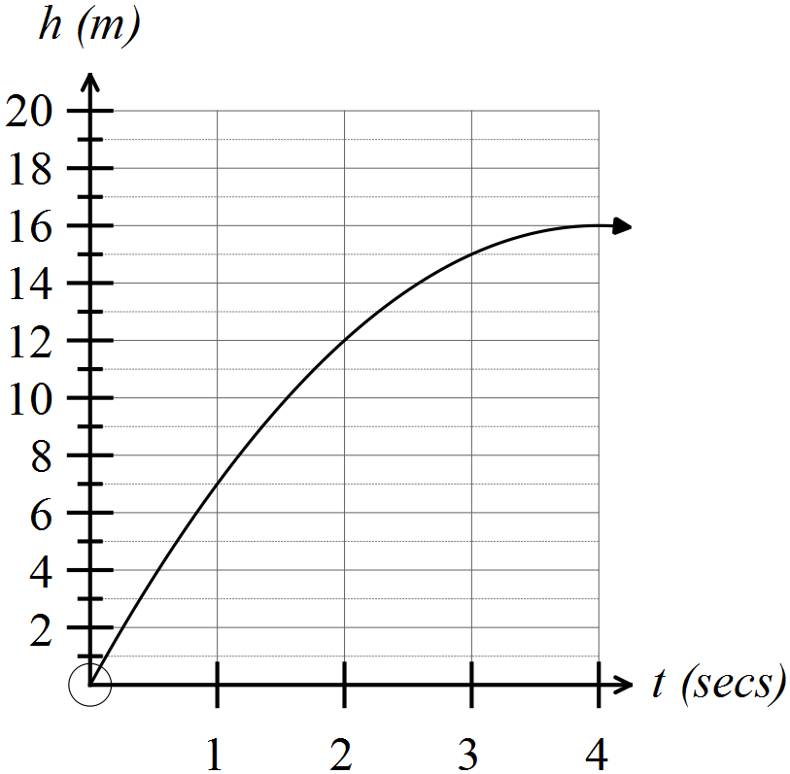

(i) Complete the tables below.

Table 1: Height reached over time.

|  |  |
| --- | --- |
| Time  (secs) | Height reached  (m) |
| 0 |  |
| 1 |  |
| 2 |  |
| 3 |  |
| 4 |  |

Table 1: Average speed of ball over time

|  |  |  |
| --- | --- | --- |
| *n*th second of time | *n* | speed ( *s* )  (m / sec) |
| first | 1 |  |
| second | 2 |  |
| third | 3 |  |
| fourth | 4 |  |

(ii) Determine the rule for the relationship between *s* and *n*?

(iii) Describe how the average speed of the ball over each second changes as time increases.

(iv) Calculate the average speed of the ball over the first 4 seconds.

**Question 4 (7 marks)**

For other moving objects the table below shows the formulae for the two relationships examined in previous questions.

A: The distance (*d*) travelled for each second of time (*t*) that has passed.

B: The average speed (*s*) over each second (*n*) of motion.

|  |  |  |  |
| --- | --- | --- | --- |
| Object | Distance formula | Type of relationship | Formula for average speed |
| 1 |  |  |  |
| 2 |  |  |  |
| 3 |  |  |  |
| 4 |  |  |  |
| 5 |  |  |  |
| 6 |  |  |  |
| 7 |  |  |  |

(a) Identify the distance relationships for each object. Enter the **type** of these relationships for each object in the table provided. (4)

(b) What appears to be the pattern between the types of relationships for distance and speed? Justify your conclusions by referring to the relationships in the table above. (3)

**Question 5 (8 marks)**

**Investigating speed at a point in time.**

The distance (*d*) an object travels can be described by the rule *d* = 2*t* 2 where *t* represents the number of seconds that have passed. The average speed during the third second can be calculated as follows



But what about the speed the object is travelling when ***t* = 2, i.e. t is exactly 2**? Are these the same? To investigate this question, the average speed “from the point in time” when *t* = 2 is considered.

(a) Calculate the average speed for the time from *t* = 2.0 until *t* = 2.5 as follows. (1)



(b) Is the value calculated in part (a) a more accurate reflection of the speed at *t* = 2 than the 10 m/sec given? Justify your choice. (2)

(c) To get closer to the speed at *t* = 2, smaller intervals are chosen and the average speed for those time intervals are calculated. Some of the calculations and results are given in the table below. Complete the table. (3)

|  |  |  |  |
| --- | --- | --- | --- |
| From | To | Calculation for average speed | Speed  (m/sec) |
| *t* = 2.0 | *t* = 2.5 |  |  |
| *t* = 2.0 | *t* = 2.1 |  |  |
| *t* = 2.0 | *t* = 2.01 |  |  |
| *t* = 2.0 | *t* = 2.001 |  |  |
| *t* = 2.0 | *t* = 2.0001 |  |  |

(d) Comment on the pattern appearing in the table with respect to the speed of the object at *t* = 2. (2)